**PIZZA SALES SQL QUERIES**

1. 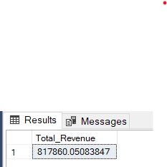**KPI’s**

**1.Total Revenue:**

**select sum(total_price) as Total_Revenue from pizza_sales;**

**2.AVERAGE ORDER VALUE:**

**select sum(total_price) / count(DISTINCT order_id) as Avg_Order_Value from pizza_sales;**

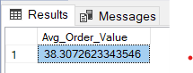

**3. TOTAL PIZZA SOLD:**

select sum(quantity) as Total_Pizza_Sold from pizza_sales;

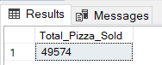

**4. TOTAL ORDERS:**

select COUNT(DISTINCT order_id) as Total_Orders from pizza_sales; 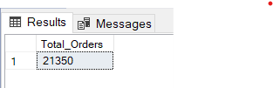

**5. AVERAGE PIZZA PER ORDER: The average no pizza sold per order, calculated by deviding the total no pizzas sold by the total no of orders**

select cast(cast(sum(quantity) as DECIMAL (10,2)) /

cast(count(distinct order_id) as DECIMAL (10,2)) as DECIMAL (10,2))

as avg_pizza_per_order from pizza_sales;

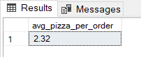

**B.Requirement**

**1.DAILY TRENDS FOR TOTAL ORDERS:**

Select DATENAME(DW, order_date) as order_day, COUNT(DISTINCT order_id) as Total_Orders

from pizza_sales

group by DATENAME(DW, order_date);

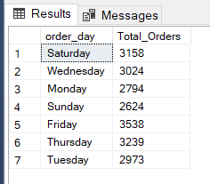

**2.MONTHLY TRENDS FOR TOTAL ORDERS:**

select datename(Month, order_date) as Order_Month, COUNT(distinct Order_id) as Total_orders

from pizza_sales

group by DATENAME(MOnth, order_date)

order by COUNT(DISTINCT order_id) desc;

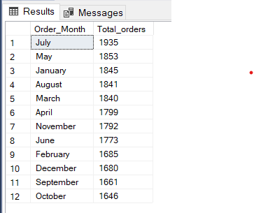

**3.PERCENTAGE OF SALES BY PIZZA CATEGORY:**

SELECT pizza_category, sum(total_price) as Total_sales, sum(total_price) * 100/ (select sum(total_price) from pizza_sales) as PCT

from pizza_sales

group by pizza_category;

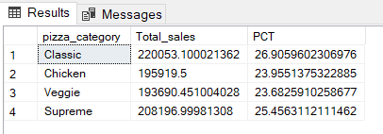

**4.PERCENTAGE OF SALES BY PIZZA SIZE:**

SELECT pizza_size, sum(total_price) as Total_sales, sum(total_price) * 100/ (select sum(total_price) from pizza_sales) as PCT

from pizza_sales

group by pizza_size

order by PCT DESC;

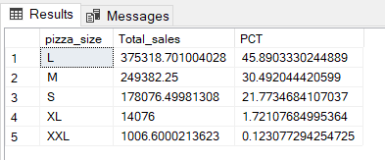

**5.TOTAL PIZZA SOLD BY PIZZA CATEGORY:**

select pizza_category, sum(total_price) as total_sales, sum(total_price) * 100/(select sum(total_price) from pizza_sales) as PCT

from pizza_sales

group by pizza_category

order by PCT DESC;

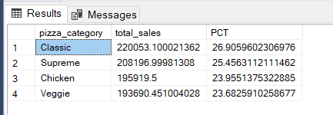

**6.TOP 5 BEST PIZZA BY REVENUE:**

SELECT Top 5 pizza_name, sum(total_price) as Total_Revenue

from pizza_sales

group by pizza_name

order by Total_Revenue DESC;

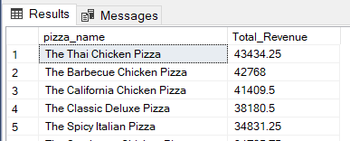

**7.BOTTOM 5 BEST PIZZA BY REVENUE**

select Top 5 pizza_name, sum(total_price) as Total_Revenue

from pizza_sales

group by pizza_name

order by Total_Revenue ASC;

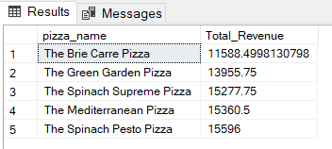

**6.TOP 5 BEST PIZZA BY QUANTITY:**

SELECT TOP 5 pizza_name, sum(quantity) as Total_Quantity

from pizza_sales

group by pizza_name

order by Total_Quantity DESC

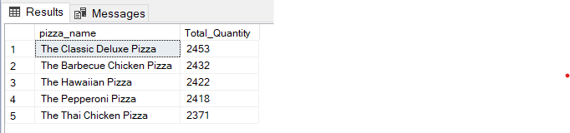

**7.BOTTOM 5 BEST PIZZA BY QUANTITY:**

SELECT TOP 5 pizza_name, sum(quantity) as Total_Quantity

from pizza_sales

group by pizza_name

order by Total_Quantity ASC;

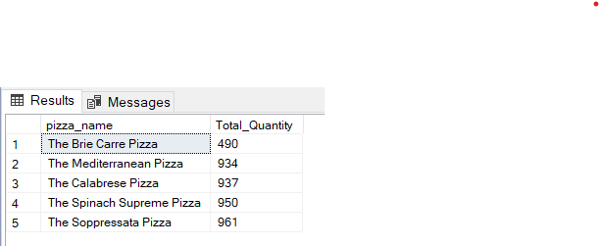

**8. TOP 5 BEST PIZZA BY TOTAL ORDERS:**

Select top 5 pizza_name, count(DISTINCT order_id) as Total_Count

from pizza_sales

group by pizza_name

order by Total_Count DESC;

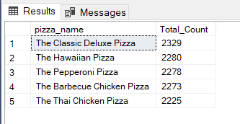

**10.BOTTOM 5 BEST PIZZA BY TOTAL ORDERS:**

Select top 5 pizza_name, count(DISTINCT order_id) as Total_Count

from pizza_sales

group by pizza_name

order by Total_Count ASC;

